

CST4390: Postgraduate Individual Project

The Impact of a Sedentary Lifestyle on Health: A Data-Driven Approach to Identifying Patterns and Solutions

Coursework 2: Intermediate Deliverable
Submission: Monday 11th August 2025
Word Count: 3414

Student ID:M00810926

Name: Abdullahi Mohamed

CAMPUS: HENDON

Table of Contents
Introduction…………………………………………………………………………………………………………. Page 3
Relevant Literature………………………………………………………………………………………………. Page 4-6
Excel……………………………………………………………………………………………………………………… Page 7-17
SQL………………………………………………………………………………………………………………………. Page 18-25
Tableau…………………………………………………………………………………………………………………. Page 26-30
Results Analysis……………………………………………………………………………………………………… Page 31-32
Conclusion ……………………………………………………………………………………………………………. Page 33
References ……………………………………………………………………………………………………………. Page 34

Chapter 1 Introduction
In recent times, sedentary behaviour has become a growing public health concern, particularly as modern lifestyles include prolonged sitting due to remote working, digital learning, and home entertainment. Extensive use of sedentary time has been associated with a range of negative health outcomes such as poor-quality sleep, elevated stress and reduced psychological well-being. As physical inactivity continues in different demographics, understanding its broader impact is essential for informing effective health interventions. This project investigates the relationship between sedentary behaviour, mental and physical health indicators such as sleep quality, mood, stress, and BMI. Using third-party dataset, the project will analyse the trends across age and occupational groups. Tools such as Excel, SQL, and Tableau will be used to explore and visualise these patterns, the aim is to identify risk factors and inform anyone that benefits of a balanced lifestyle regardless of demographic, occupational and physical appearance.

Chapter 2: Relevant literature
2.1 Sedentary Lifestyle
A minimalistic lifestyle is global concern to which (Part et al, 2020) conducted research that one-third of adults worldwide are not engaging in enough physical activity. Average sedentary time is over 7 hours in many countries, to which prolonged inactivity can lead to health issues. Therefore, reducing sedentary time and increasing physical activity is important to prevent public health outcomes.
Salman et al. (2019) highlights extended periods of inactivity are linked to conditions such as cancer. It investigates sitting long hours increases the risk of early death and these effects are not reduced even by regular intense exercise. Replacing sitting time with light activity can lead to reducing blood sugar and cholesterol levels. The research emphasises healthcare workers unaware of how harmful sedentary behaviour can be and not inform patients.
Lavie et al. (2019) explores how sedentary behaviour, cardiovascular diseases, and physical inactivity all correlate. They emphasize that sedentary behaviour is a unique health risk, even if the participant meets physical activity guidelines may still be at risk if they spend large amount of time sitting still. This study depts improving fitness through regular activity is crucial in preventing chronic illnesses like heart failure. The research paper believes an effort should be made to reduce sedentary time and promote movement across all populations. This aligns with the aims of the project to identify patterns in sitting behaviour across demographics and linking them to health outcomes such as sleep quality, mood, and stress.
2.2 Sleep Quality & Physical Activity
Wang et al. (2019) displayed an understanding of physical activity and sleep quality, with an identification of 14 studies published between 2010 and 2018 analyses impact of the moderate physical activity on sleep quality. The results revealed that moderate exercise was more useful than any other to style of training to improve quality sleep regardless of age demographics. The review depts physical activity is beneficial for sleep but that intensity of exercise plays a critical role in determining its effectiveness.
Lopes et al. (2022) emphasises of sleep deprivation on endurance performance, this literature reviews highlights sleep deprivation impairs endurance performance, with a moderate negative effect size. This impact was common across distinct levels of training status and exercise modes. However longer exercises were more affected by sleep deprivation compared to shorter ones. The findings highlight partial and total sleep deprivation decreases performance across activities such as running and cycling. This study is relevant to the project as it establishes the link between sleep quality and physical performance.
Papatriantafyllou et al. (2022) conducts a narrative review examining how sleep deprivation affects eating behaviours and weight regulation. This review highlights that short sleep duration is linked with increased energy intake, from fat and sugar. Study display how adults sleeping fewer than seven hours are a greater risk of weight gain and associated metabolic disorders. These findings suggest that sleep quality and duration should be considered when supporting individuals are aiming to lose or maintain weight. This is relevant to the current project highlighting how sleep patterns interact with physical activity to influences health outcomes.
2.3 Mental Health, Stress & Exercise
Fossati et al. (2021) navigates the relationship between physical exercise and mental health, implying how each can influence each other. The review conducted convincing evidence supporting the positive impact of regular physical activity both competitive on mental health outcomes such as reduced stress, anxiety, depression, and social isolation. While the effect of mental fitness on physical performance is less studied, the review also noted that poor mental health, including symptoms of anxiety and depression, can increase the risk of sports injuries Aswell. Inconsistencies in study design and reliance on correlational data limit clear conclusion about causality. These findings support the project’s focus on integrating physical activity into their lifestyle, for improving psychological resilience and reducing the mental health burden in diverse groups.
Merino et al. (2024) explores how body image perceptions, social media, and physical measurements affect psychological well-being, with a focus on cultural and gender differences. This study highlights how social media application causes body dissatisfaction through exposure to idealized body types, fostering low self-esteem, depression, and disordered eating. Physical attributes such as BMI, weight and height are oftens perceived as worth or attractiveness intensifying mental health issues. Cultural norms and gender expectations shape these perceptions, to which resorting to physical fitness can uplift an individual and be proud of their appearance.
2.4 Relevancy to Project
The literature reviews all have a direct impact on the project methodology as it aligns with how sleep quality and physical activity correlates, the importance of mental health and being aware of your sedentary behaviour. The integration of these research papers provides an outlet for the project, examining indicators that causes sedentary behaviour, to which the aim is to identify points that could maximise health benefits across multiple variables. Not focusing on a specific aspect allows for a broader and more sophisticated approach in finding out the negatives of sedentary behaviour. This approach strengthens the project’s potential contribution to the field by addressing gaps in the understanding how health behaviours affect an individual.

Chapter 3: Excel
3.1 Survey dataset – Stress, Mental Health, and Fitness Impact
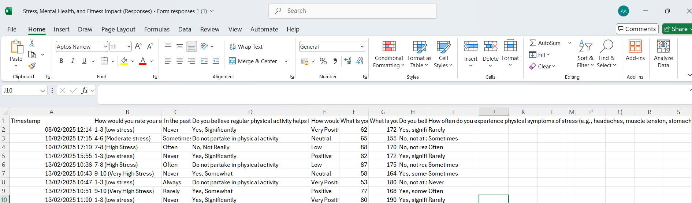
Figure 1 - Dataset 1
This is the first dataset that will be cleaned and data processed.
3.2 Find and replace.
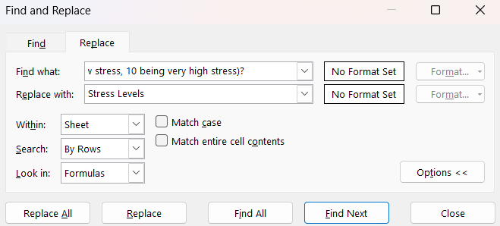
Figure 2 - Find and Replace
Multiple rows will be replaced using the find and replace,

3.3 Removal of Columns
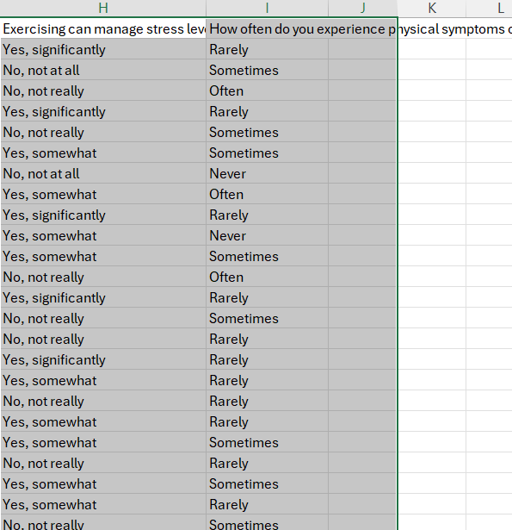
Figure 3 - Column Removal
These two columns have little relevance to the methodology of project.

3.4 Remove Duplicates
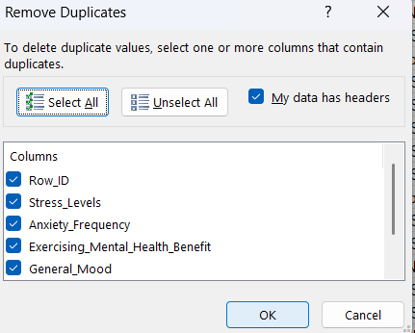
Figure 4 - Remove Duplicates

Figure 5 - Results of Duplicates
3.5 Data Analysis Excel
Zero duplicates were found in all datasets with proof of screenshot.
Create new columns (Excel Formula)
=ROUND(F2/(G2/100)^2,1) - CREATE BMI Column
=IF(H2<=25,"Normal Weight","Overweight") - weight category
Q1) Is there a correlation between having a cheerful outlook and exercising.
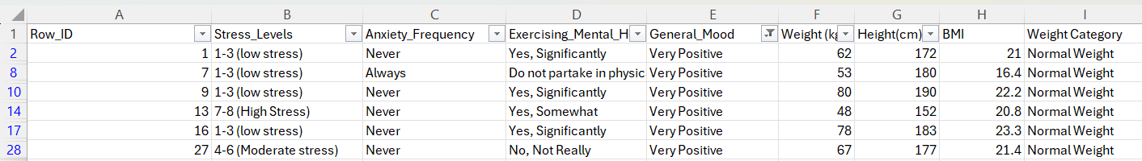
Figure 6 - Excel Q1
All participant that has a positive mood are of normal weight in BMI scale with 4 out of the 6 believe their physical exercise routine contributes with their positive mood.
Data Analysis Q2) Count how many people say activity helps their mental health.
- =COUNTIFS(D2:D36,"Yes, significantly") = 7
- Yes 7 out of 30 believe majorly physical activity help with their mental health.
Data Analysis Q3) How many participants are in a positive Mood without exercising?
- =COUNTIFS(D2:D36,"Do not partake in physical activity",E2:E36,"Positive") = 1
- =COUNTIF(D2:D36,"Do not partake in physical activity")= 5
- 1 in 5 users are in a good mood that do not exercise.
3.6 Updated Dataset
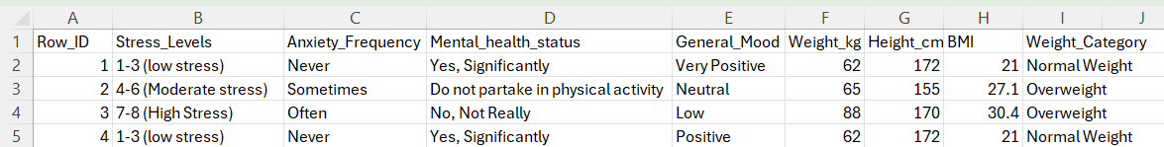
Figure 7 - Dataset 1 - Updated Dataset
3.7 Sedentary and Behaviour – Dataset 2
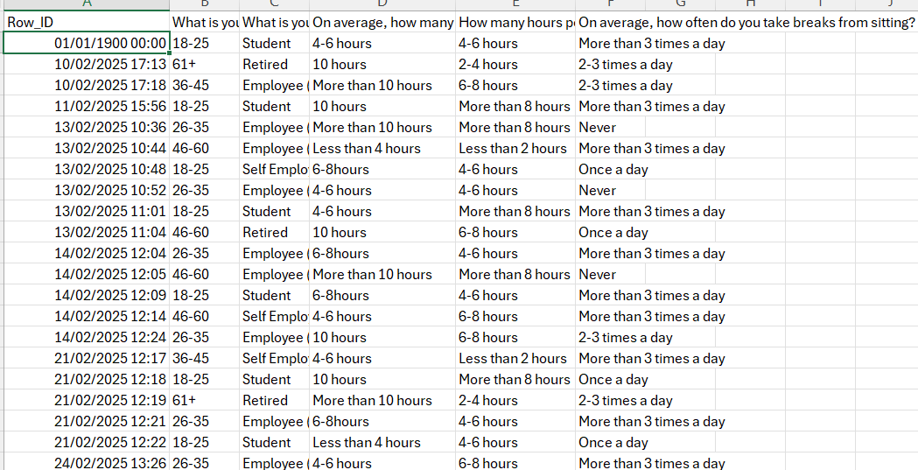
Figure 8 - Dataset 2
This is section of the second dataset.

3.8 Formula for Row ID
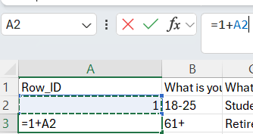
Figure 9 - Row ID
Remove timestamp to Row_ID to ensure there is joining key later for SQL.
3.9 New Row Name
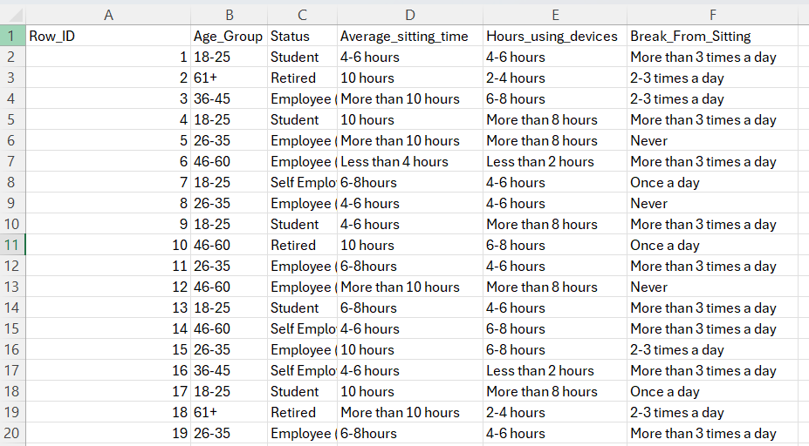
Figure 10 - New Row Name
Now all the numbers are ascending to which conforms with data processing rules.

3.10 Observation of students
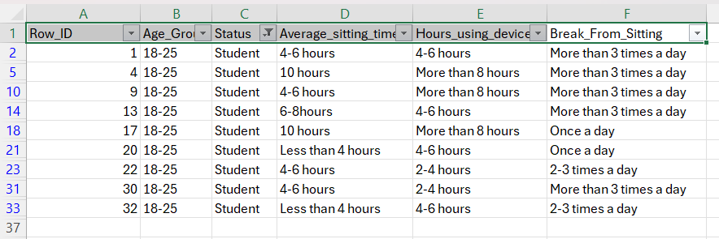
Figure 11 - Student observations.
Students who get up from sitting down are usually young, due to university workload making them want to frequent breaks.
3.11 Age group by average sitting time (Pivot Table)
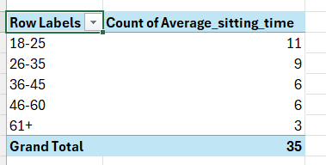
Figure 12 - Age group by sitting time.
The older the age group, the less they are likely to sit down possibly due to being aware of the risks of sedentary behaviour.

3.12 Age group by average sitting time (Pivot Chart)
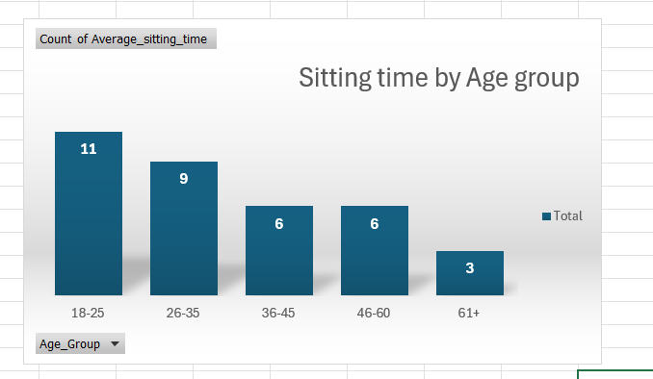
Figure 13 - Pivot Chart
A visualization of the sitting time by age group.
3.13 Occupation by sitting time (Pivot Table)
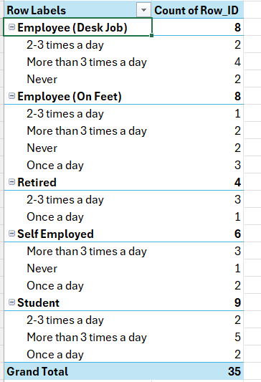
Figure 14 - Pivot Table for Occupation sitting time.
Students are the likeliest to get up the most out of all occupation possible due to their youthful age and lack of job responsibilities.

3.14 Excel Sedentary questions
Data Analysis Q4) Who sits for 10 hours and takes just one breaks?
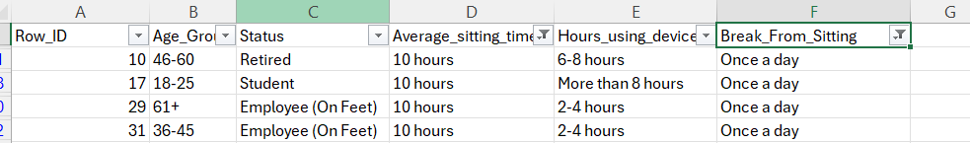
Figure 15 Excel Q4
All types of age group sit for over 10 hours, highlighting the strain of an eventual day can take a toll on anyone.
Data Analysis Q5) How many 18-25 students sit for 6-8 hours and take more than 3 breaks a day?
Figure 16 - Excel Q5
Just 1 student is able to sit for 6-8 hours and take more than 3 breaks to which indicates they are genuinely like into physical training.
Data Analysis Q6) How many employees (desk job) sit for more than 10 hours?
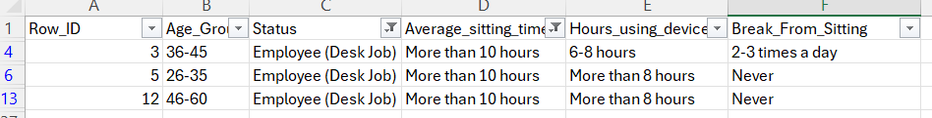
Figure 17 - Excel Q6
Desk job employees sit for more than 10 hours which causes sedentary behaviour regardless of age group.
Data Analysis Q7) Which participants sits for more than 8 hours, use devices more than 6 hours and never take breaks.
Figure 18 - Excel Q7
Employees who work a desk job in the survey, this highlights the intensity of a desk job, due to the demand of meeting clients’ expectations.
3.15 - Dataset 3 – Physical Activity and Sleeping Pattern Original Dataset
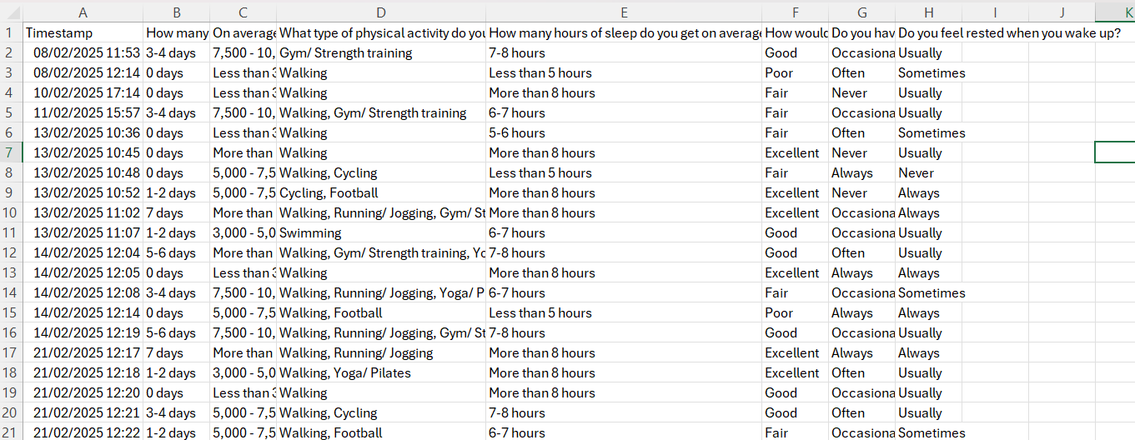
Figure 19 - Dataset 3
3.16 Renamed columns names.
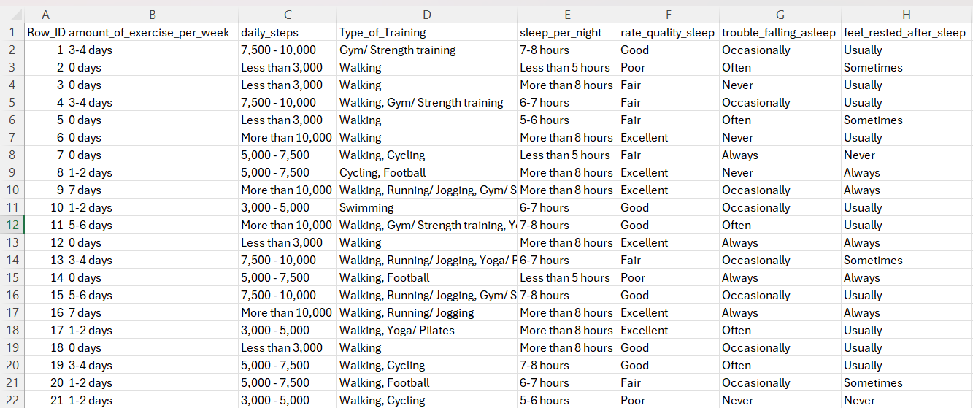
Figure 20 - Change column names.
3.17 Exercise and sleep quality questions
Data Analysis Q8) Who doesn't exercise and sleeps poorly?
Figure 21 - Excel Q8
All 3 individuals who don’t exercise rated their sleep quality poorly.
Data Analysis Q9) Who exercises daily and always feels rested?
Figure 22 - Excel Q9
Exercising daily who rate their quality sleep as excellent, implying the importance of having an active lifestyle.
Data Analysis Q10) How many people exercise 5+ days and feel rested “Always”?
Figure 23 - Excel Q10
Out of 8 people who exercise over 5 days a week, half of them always feel great when they wake up.
Data Analysis Q11) Who gets more than 8 hours of sleep and reports “Excellent” sleep quality?
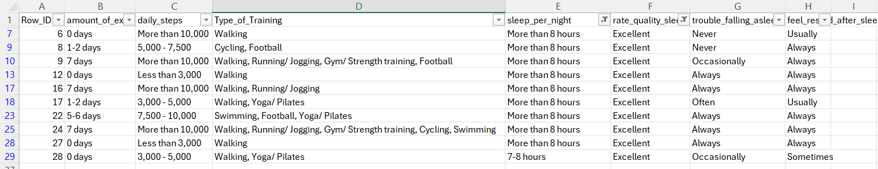
Figure 24 - Excel Q11
Sleeping more than 8 hours is highly likely to lead to an excellent sleep however long it takes you to fall asleep.
3.18 Pivot Table Exercise vs Sleep Quality
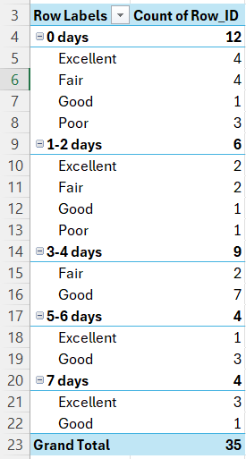
Figure 25 - Pivot Table Exercise Vs Sleep Quality
Exercising more than 4 days depicts an excellent quality sleep and having lower quality sleep usually corresponds to minimal exercise.
3.19 Pivot Chart Exercise vs Sleep Quality
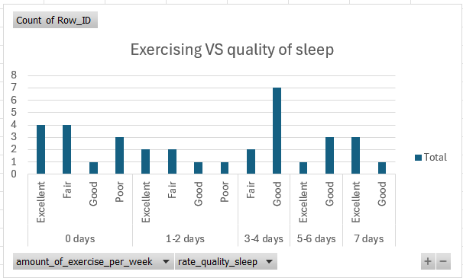
Figure 26 - Pivot Chart Exercise vs sleep quality.
3.20 Pivot Table Daily Steps vs Feeling Rested
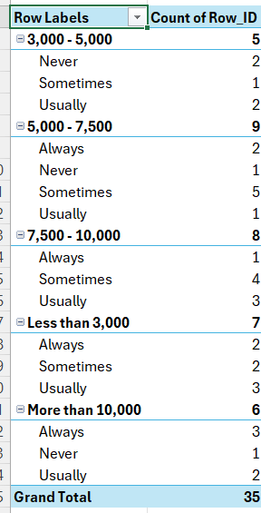
Figure 27 - Pivot Table Daily Steps vs Feeling Rested
The results vary with the daily steps not corresponding to feeling rested, whether a participant has taken minimal steps or over 10 thousand, they feel similar after waking up.

Chapter 4. SQL
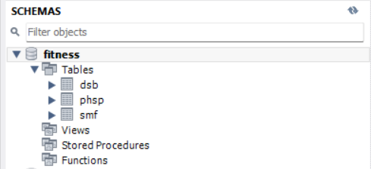
Figure 28 - SQL Schema importing datasets.
Creation of database, importing tables from excel using a CSV file.
4.1 Sedentary Behaviour and Mental Health Correlation:
4.2 Find the top 5 highest stress level per age group sitting time?
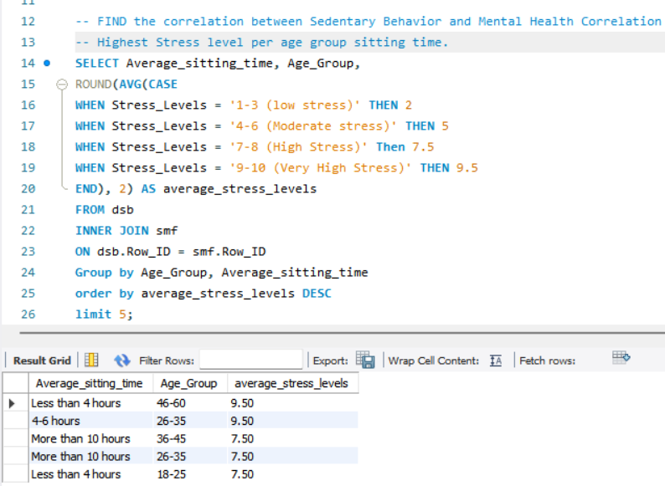
Figure 29 - Highest Stress Levels
The query depicts they can be equally stressed regardless of their sitting time and age group.

4.3 Find the top 5 lowest stress level per age group sitting time?
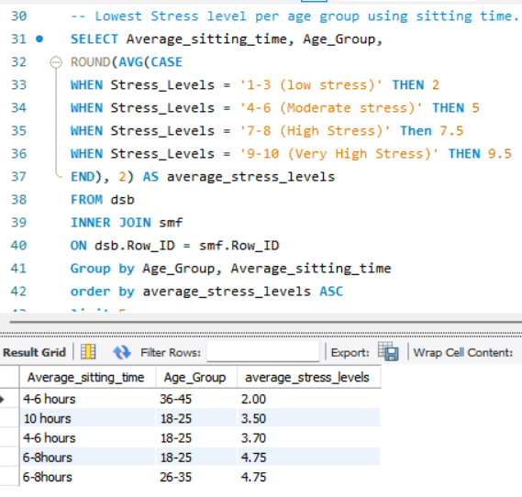
Figure 30 - Lowest Stress Levels
18-25 are likely to be the least stress due being students and not having many major responsibilities.
4.4 Find if device usage impact on sleep quality?
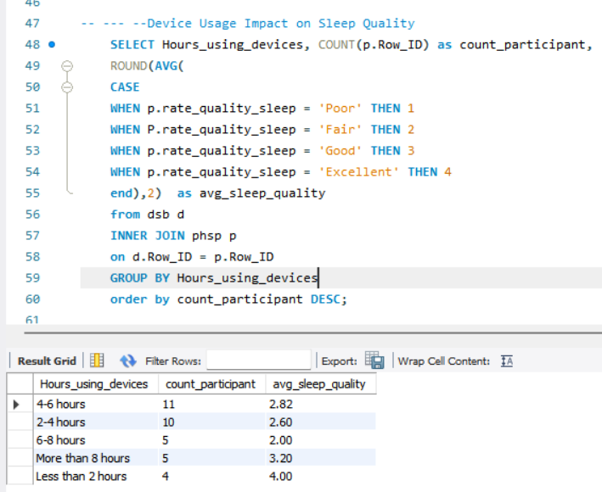
Figure 31 - Device usage sleep quality.
Yes, using your smart devices for less than 2 hours leads to an excellent amount of sleep. However, device usage regardless of amount of time leads to a fair amount of sleep.

4.5 Does a break from sitting time impact anxiety?
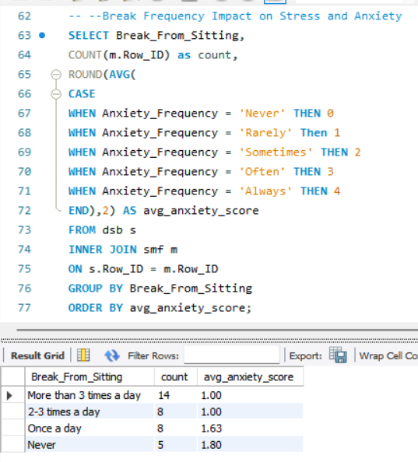
Figure 32 - Break from sitting.
Yes take 3 or more breaks from sitting leads to rare anxiety rates whilst never taking a break can potentially lead to anxious traits.
4.6 Does exercising lead to a troubled sleep or not?
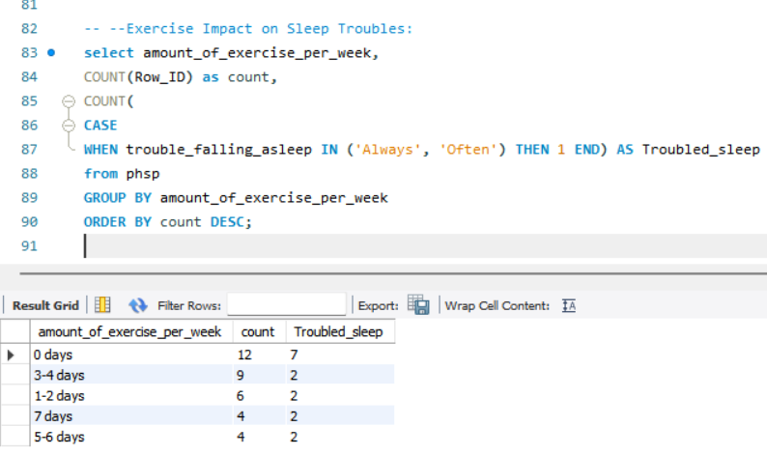
Figure 33 - Exercise correlation to sleep.
Not exercising at all is likely to lead to a troubled sleep, whilst exercising even just 1 or 2 days is likely to not lead to a troubled sleep.

4.7 Does the daily step correlate with positive mood?
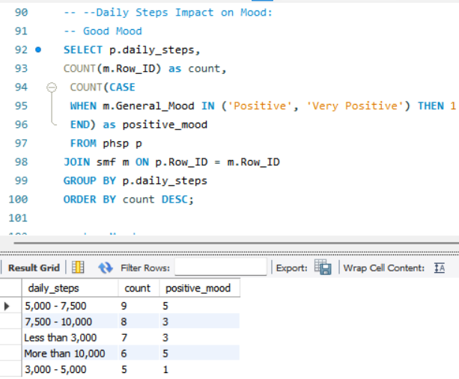
Figure 34 Mood vs Daily Step Count
Yes, taking minimal steps daily can lead to not a positive mood but high number of steps can lead to a positive mood.

4.8 Does the daily step correlate with having a low mood.
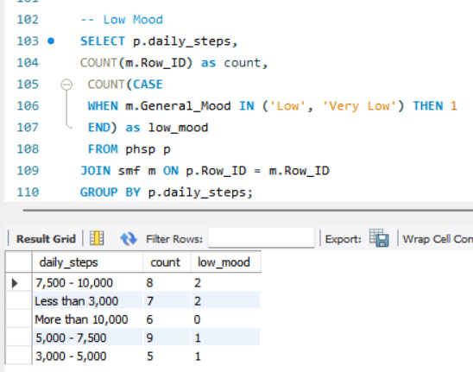
Figure 35 - Low mood vs daily step count.
Yes, the likeliest group with a low mood is taking less than 3 steps.
4.9 Find the age group with the highest sedentary behaviour.
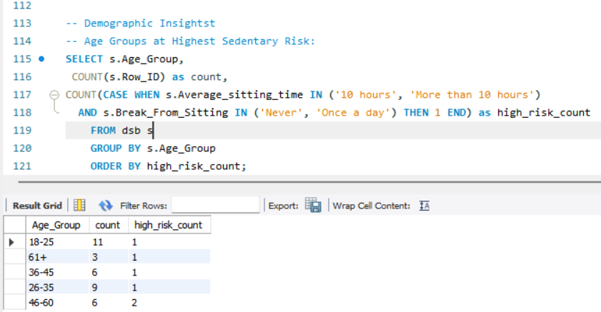
Figure 36 - Highest age group.
1 out of 3 over the age of 61 partake in a high amount of sedentary behaviour whilst age 18-25 are the least likely to display this type of behaviour.
4.10 Find correlation between occupational impact on BMI?
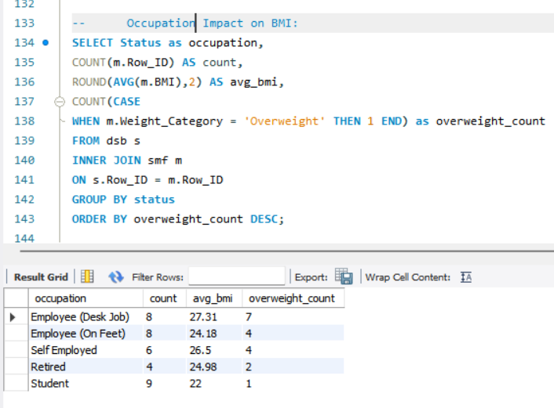
Figure 37 - BMI vs occupation.
Desk job employees have the highest BMI and overweight group whilst students have the least and the healthiest weight range.
4.11 Mental Health by Age Group and Exercise of students?
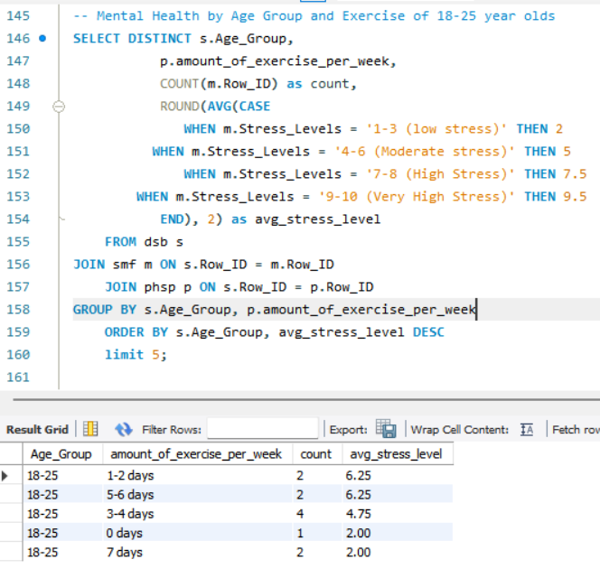
Figure 38 - Mental Health by Age Groups
Students regardless of the exercise frequency does not have a correlation with their mental stress levels as both daily exercise and zero amounts of physical activity are both in the low stress category.

4.12 Sleep Quality, Exercise and BMI relationship.
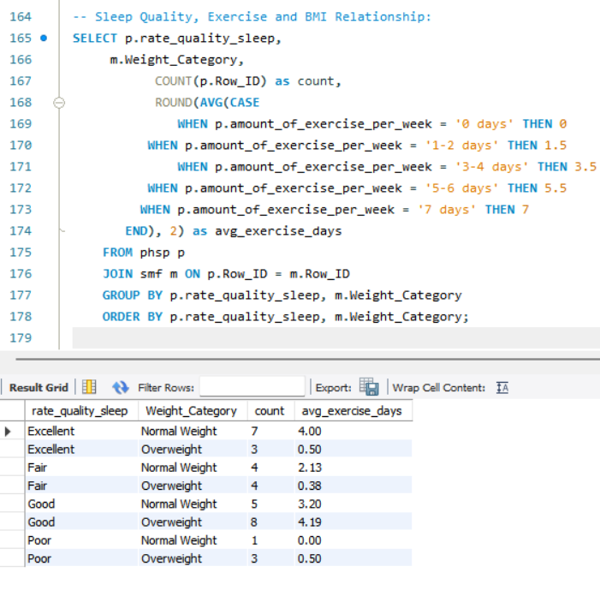
Figure 39 - Sleep Quality, Exercise and BMI relationship.
Yes exercising 4 days per week and being normal weight and having an excellent is common. Also being overweight and exercising 4 days a week leads to an excellent quality sleep indicating a weight loss journey. The one individual who doesn’t work out at all is the only normal weight person with a poor-quality sleep highlights a poor sedentary lifestyle.

Chapter 5. Tableau
5.1 Sedentary Behaviour by Demographics
Bar chart showing average sitting time by age group.
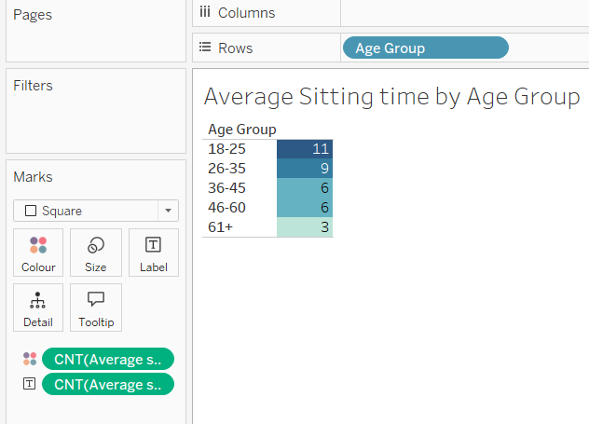
Figure 40 - Sedentary Behaviour by Demographics
A visualization of various age group and their sitting time, with it going down in ascending order.
5.2 Bar chart showing average sitting time by occupation (status)
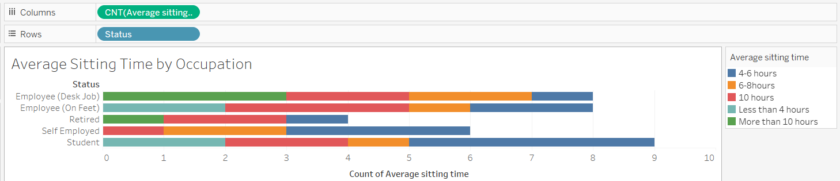
Figure 41 Average sitting time by occupation.
Students sitting for 4-6 hours to potentially get their work done whilst employees working on feet are the likeliest to sit for 10 hours after a long shift, they are drained.

5.3 Sitting Time Vs Usage
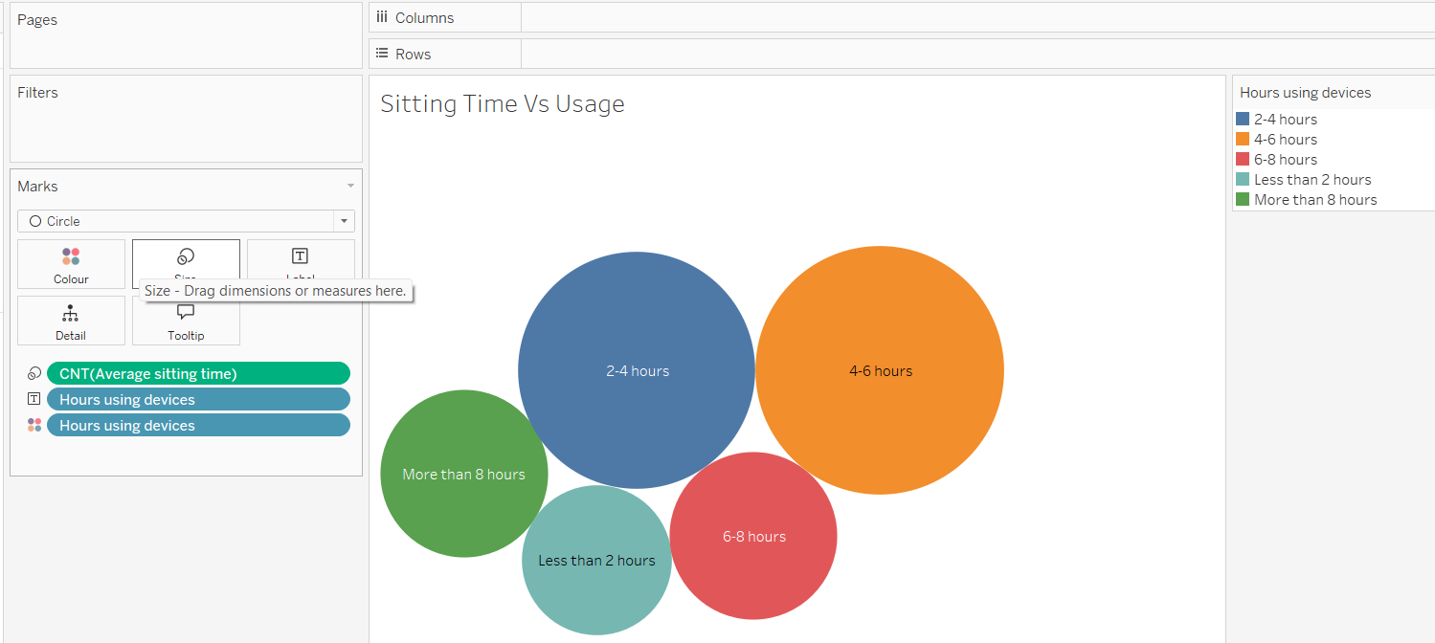
Figure 42 - Pie Chart
Sitting down and using a device is at most peal for 4-6 hours which is the standard daily amount.
5.4 Device Usage and Break Analysis
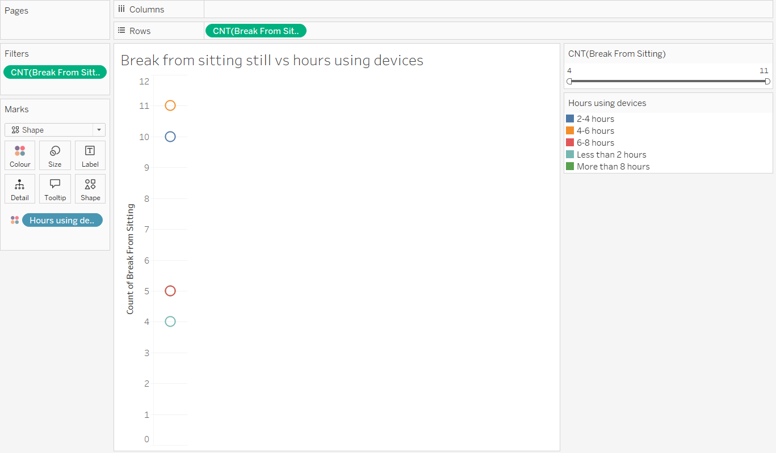
Figure 43 - Device Usage
Every participant who takes a break from sitting down does not use their device for more than 8 hours.

5.5 Stacked bar chart showing break frequency by occupation.

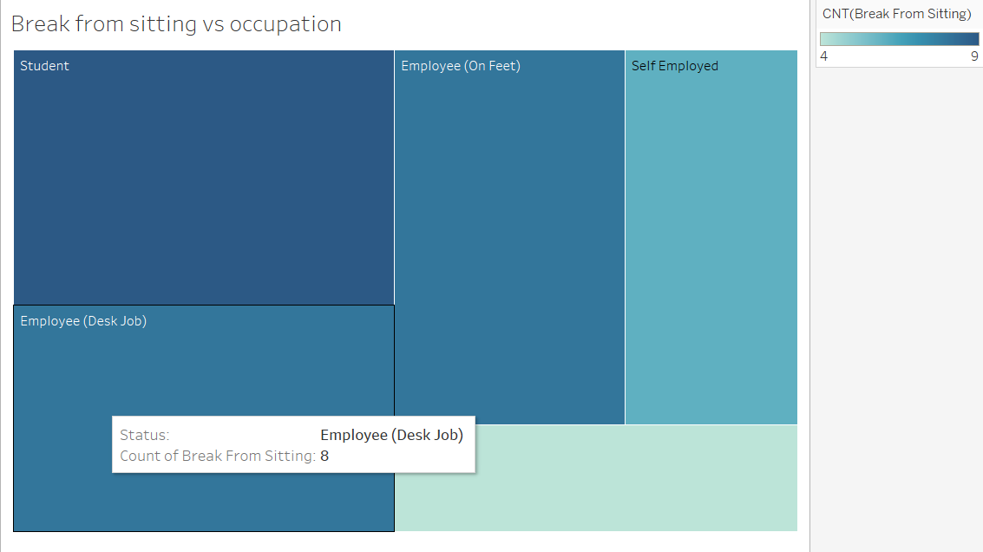
Figure 44 - Bar Chart

Students and employees in a desk job take a break from sitting whilst self-employed take a lot less, potentially due them being at the forefront of the business.

5.6 Exercise Impact on Sleep Quality Dashboard
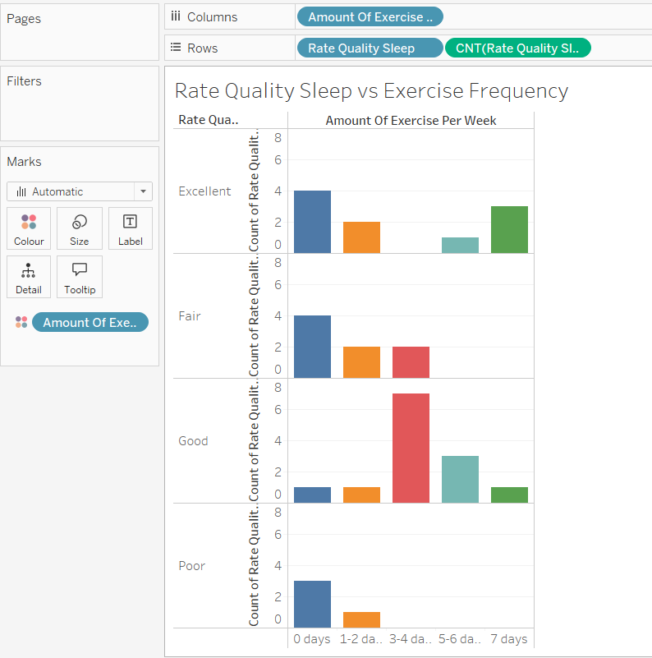
Figure 45 - Exercise impact on sleep quality dashboard.
Getting a good amount of sleep is correlated with 3-4 days of exercising once again. Exercising 7 days a week can lead to an excellent sleep whilst exercising zero days can lead to a variety of sleep quality.
5.7 Daily Steps and Sleep Patterns Dashboard
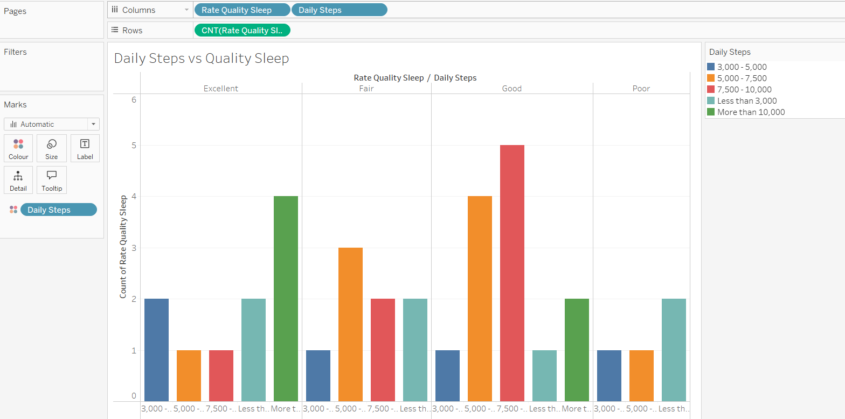
Figure 46 - Daily steps and sleep patterns dashboard.

Taking near around 10k steps leads to the best quality sleep and the second-best category that leads to an excellent sleep take more than 10k steps.
5.8: BMI and Mental Health Correlation Dashboard
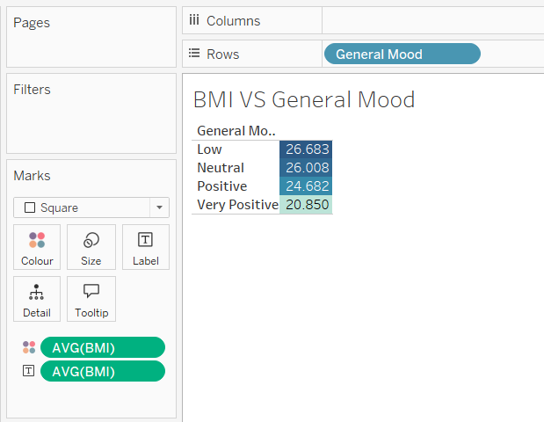
Figure 47 - BMI and Mental Health correlation.
Having a cheerful outlook links with BMI, as the greater the mood the healthier the BMI is. With an incredibly positive mood being 20.8 and a low mood having a 26.7 BMI.

Chapter 6. Results Analysis
This research project has made use of data analytical tools such as Tableau, SQL, and Excel to understand the relationship between sedentary behaviour, physical activity levels, sleep quality, and mental health across various demographic groups. The results revealed actionable insights that contribute to understanding how lifestyle choices can impact overall wellbeing. The analysis confirmed that sedentary behaviour presents unique challenges such as potential health risks regardless of age range, occupation, and demographic. Desk job employees recorded the highest sitting times and BMI measurements, highlighting occupational risk factors for sedentary behaviour. Students recorded the highest amount of screen time, however, took the most breaks from sitting down, highlight their age may help in reducing sedentary behaviour.
A clear link occurred with physical activity and sleep quality, to which participants who exercised 3-4 days per week reported higher quality sleep than , non-physically active participants. Majority of participants who reported no exercise rated their sleep poorly and those how exercised daily felt rested after waking up. This relationship is further cemented by daily step data, with participants achieving approximately 10,000 steps daily all said their quality of sleep is excellent.
Mental health plays a key role in this project, to which a connection to physical activity and sedentary patterns were discovered within this project. Take breaks from sitting was associated with lower anxiety levels, while those who never took breaks reported higher anxiety frequencies. Daily step counts demonstrated a relationship between mood, as those with higher step counts consistently reported a better mood. BMI revealed a connection between weight status and mental outlook, with participants reporting positive moods averaging healthier BMI measurements (20.8) differently to those with low moods (26.7).
Usage of devices is an important variable, with using it under two hours correlates with excellent sleep quality. The data highlights participants who take breaks from sitting are very unlikely to use devices for more than eight hours, suggesting potential interventions points for reducing overall screen time. The data provides a conclusion that take regular breaks from sitting, engaging in moderate physical activity a couple times per week, managing device usage can lead to significant benefits across multiple across multiple health.
This project find relationship between variables and identifying specific behavioural patterns that appear protective against negative health outcomes. Future research explores intervention strategies targeting identified patterns, particularly for desk-based employees. Additionally, studies examining how changes in activity patterns affect sleep quality and mental health over time would further strengthen the understanding of methodology. The data-driven approach taken in this study highlights the importance of addressing sedentary behaviour as a health risk factor and provides evidence-based guidance for developing tailored intervention to promote more active lifestyles across diverse demographic groups.

Chapter 7. Conclusion
This deliverable discusses the consequences of sedentary behaviour with a comprehensive data analysis. A clear relationship is identified between physical activity, device usage and both physiological and psychological well-being.
The results include how lifestyle choices create health issues, with occupational factors playing a crucial role in sedentary behaviour patterns. Desk-based employees face set challenges such as their BMI measurement and higher sitting durations. Whilst regular physical activity correlates with improved sleep quality and mental health measures.
Digital device usage is a major factor in sedentary behaviour with extended screen time negatively impacting sleep quality and likelihood of leading to reduce physical activity. The data supports implementing practical intervention like scheduled breaks from sitting, daily step targets around 10k steps and management of device usage.
Health interventions can be implemented with the actionable insights to develop a solution for sedentary lifestyle. This research aim is to prevent sedentary behaviours and promote overall health.

8. References
Park, J.H., Moon, J.H., Kim, H.J., Kong, M.H. and Oh, Y.H., 2020. Sedentary lifestyle: Overview of updated evidence of potential health risks. Korean Journal of Family Medicine, 41(6), pp.365–373. Available at: https://www.ncbi.nlm.nih.gov/pmc/articles/PMC7700832/ [Accessed 17 Apr. 2025].
Salman, D., Farooqi, M., McGregor, A., & Majeed, A. (2019). Time spent being sedentary: an emerging risk factor for poor health. British Journal of General Practice, 69(683), 278-279. https://doi.org/10.3399/bjgp19X703781. [Accessed 21 March 2025].
Lavie, C.J., Ozemek, C., Carbone, S., Katzmarzyk, P.T. and Blair, S.N., 2019. Sedentary behavior, exercise, and cardiovascular health. Circulation Research, 124(5). Available at: https://doi.org/10.1161/CIRCRESAHA.118.312669. [Accessed 22 March 2025]
Wang, F. and Boros, S., 2019. The effect of physical activity on sleep quality: a systematic review. European Journal of Physiotherapy, 21(1), pp.11–18. Available at: https://www.tandfonline.com/doi/full/10.1080/21679169.2019.1623314 [Accessed 17 Apr. 2025].
Lopes, T.R., Pereira, H.M., Bittencourt, L.R.A. & Silva, B.M., 2022. How much does sleep deprivation impair endurance performance? A systematic review and meta-analysis. European Journal of Sport Science, 22(9), pp.1279-1292. Available at: https://doi.org/10.1080/17461391.2022.2155583 [Accessed 17 Apr. 2025].
Papatriantafyllou, E., Efthymiou, D., Zoumbaneas, E., Popescu, C.A. & Vassilopoulou, E., 2022. Sleep Deprivation: Effects on Weight Loss and Weight Loss Maintenance. Nutrients, 14(8), p.1549. Available at: https://doi.org/10.3390/nu14081549 [Accessed 17 April 2025].
Fossati, C., Torre, G., Vasta, S., Giombini, A., Quaranta, F., Papalia, R. and Pigozzi, F., 2021. Physical exercise and mental health: The routes of a reciprocal relation. International Journal of Environmental Research and Public Health, 18(23), p.12364. https://doi.org/10.3390/ijerph182312364 [Accessed 17 Apr. 2025].
Merino, M., Tornero-Aguilera, J.F., Rubio-Zarapuz, A., Villanueva-Tobaldo, C.V., Martín-Rodríguez, A., and Clemente-Suárez, V.J., 2024. Body perceptions and psychological well-being: A review of the impact of social media and physical measurements on self-esteem and mental health with a focus on body image satisfaction and its relationship with cultural and gender factors. Healthcare, 12(14), p.1396. https://doi.org/10.3390/healthcare12141396 [Accessed 17 Apr. 2025].

